Hackathon Project
Project Title:
Couture AI: AI-Powered Fashion Design with Stable Diffusion
Team Name:
SyntheStyle
Team Members:
● Nishat Unnisa
● Maryam Fatima
● Ayesha Sultana
● Thalla Varshitha
Phase-1: Brainstorming & Ideation
Objective:

Problem Statement:
Fashion design is time-consuming and costly, limiting creativity and customization. AI can automate and enhance fashion design by generating unique clothing concepts instantly.

Purpose:
To develop an AI-powered tool that creates fashion designs from text descriptions, helping designers, brands, and consumers visualize unique clothing ideas.

Impact:
Faster prototyping for designers.
Unlimited creativity with AI-generated outfits.
Personalized fashion recommendations for consumers
Key Points:
1. Problem Statement:
Fashion design is traditionally a manual, time-consuming, and expensive process that requires significant effort from designers. Customization and innovation are often limited by resources and creativity constraints. Additionally, fast fashion and mass production contribute to environmental waste, making sustainable and efficient design solutions necessary.
Current digital design tools lack AI-driven automation, which could help designers generate unique clothing concepts quickly and efficiently. Fashion brands, e-commerce businesses, and independent designers need a cost-effective way to visualize fashion ideas without physical production.

2. Proposed Solution:
We propose Couture AI, an AI-powered clothing image generator using Stable Diffusion, a deep-learning model capable of generating high-quality, realistic fashion designs from text descriptions.
- Users can enter descriptive prompts (e.g., “A futuristic evening gown with metallic textures and neon highlights”).
- AI will generate high-resolution images of the described clothing.
- This system will enable fashion designers, brands, and consumers to quickly visualize and create unique, AI-generated fashion pieces.
This solution will enhance creativity, reduce design costs, and speed up fashion prototyping, making it easier for designers and businesses to bring new styles to life.
3. Target Users:
The project aims to serve multiple stakeholders in the fashion and e-commerce industries:
✅ Fashion Designers – Helps in rapid prototyping, reducing manual sketching and allowing designers to explore new styles quickly.
✅ E-commerce & Retail Brands – AI-generated designs can be used for product visualization, virtual try-ons, and marketing campaigns.
✅ Consumers & Personal Shoppers – Users can create and visualize custom outfits tailored to their preferences.
✅ Sustainable Fashion Advocates – Reduces material waste by allowing digital-first prototyping instead of physical samples.
✅ Artists & Content Creators – Enables fashion-based AI art and unique digital clothing designs
4. Expected Outcome:
🚀 A fully functional AI-powered tool capable of generating high-quality clothing designs based on text descriptions.
🎨 Enhanced creativity and design efficiency by allowing users to explore limitless fashion styles.
💰 Cost-effective solution for fashion businesses to prototype and market new designs without production costs.
🌱 Sustainable fashion innovation, reducing material waste by relying on digital fashion prototyping.
📈 Potential for integration with fashion retail platforms for virtual try-ons and AI-powered clothing recommendations.

Phase-2: Requirement Analysis
Objective:
The project utilizes Stable Diffusion to generate fashion designs and animations based on user prompts. It requires Python, GPU support (CUDA), and dependencies like torch, diffusers, and gradio. Users input a fashion concept, adjust inference steps and animation frames, and receive an AI-generated design along with an animated GIF. The project optimizes performance with GPU acceleration and efficient model loading, ensuring smooth execution and high-quality outputs.

Key Points:

1. Technical Requirements:
- Languages & Frameworks: Python, PyTorch
- Tools & Libraries:
  - torch(for deep learning computations)
  - diffusers (Stable Diffusion model for image generation)
  - gradio (for interactive web UI)
  - PIL (for image processing)
  - os (for file handling)
- Hardware Requirements:
  - GPU (CUDA-enabled) recommended for better performance
  - CPU fallback available but with slower processing
- Model Used: runwayml/stable-diffusion-v1-5
2. Functional Requirements: (Features the project must have)
Fashion Design Generation:
- Accepts user input as a text prompt
- Uses AI to generate fashion-related images
Animation Feature:
- Generates multiple frames for design variations
- Creates and saves an animated GIF
User Interface:
- Built with gradio
- Inputs:
  - Textbox for user prompts
  - Sliders to adjust inference steps (10-100) and animation frames (3-10)
- Outputs:
  - Static image preview
  - Animated GIF of generated designs

3. Constraints & Challenges:
High GPU Requirement:
  - Performance significantly improves with CUDA-enabled GPUs
- Memory Usage:
  - Pre-trained Stable Diffusion models are large and require substantial VRAM
- Processing Time:
  - More inference steps and animation frames increase generation time
- AI Output Limitations:
  - Designs depend on model training data and may not always match user expectations precisely

Phase-3: Project Design
Objective:
The system follows a structured flow from user input to AI-generated fashion designs and animations. Below is a simple breakdown:
- User Input (via gradio interface)
- Processing Layer
  - Text prompt is received
  - Stable Diffusion model (runwayml/stable-diffusion-v1-5) processes input
  - AI generates multiple frames of fashion designs
- Output Layer
  - First frame saved as an image (fashion_design.png)
  - All frames compiled into an animated GIF (fashion_design_animation.gif)
- Display Results
  - Image and GIF are shown to the user in grade.

. System Architecture Diagram
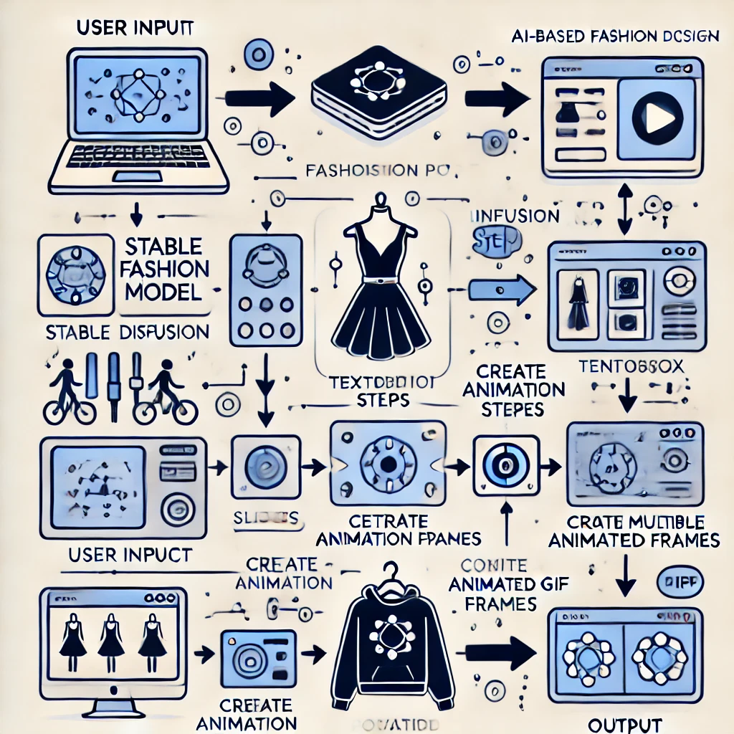

2.User Flow
Step 1: User opens the Gradio interface
Step 2: Enters a fashion-related text prompt
Step 3: Adjusts parameters:
- Inference Steps: Controls detail level
- Animation Frames: Defines GIF length
Step 4: Clicks Generate
Step 5: AI processes the request and creates designs
Step 6: User receives:
- A static fashion design image
- An animated GIF preview
Step 7: Option to save/download results
3. UI/UX Considerations:
- Simple & Intuitive UI using gradio
- Input Fields:
  - Textbox for prompt
  - Sliders for customization
- Output Display:
  - Clear preview of generated images
  - Animated GIF preview for better visualization
- Minimalist Layout:
  - Focus on user experience with easy-to-understand options
  - Fast response and loading times for better engagement

Phase-4: Project Planning (Agile Methodologies) ObjectiveBreak down the project tasks using Agile methodologies to ensure efficient development and delivery.
Key Points:
1. Sprint Planning:

1. Sprint Planning (Dividing Work into Tasks)
The project is broken into multiple sprints, each focusing on a specific development phase.

Sprint 1: Setup & Research
- Install required dependencies (torch, diffusers, gradio)
- Set up the Stable Diffusion model
- Ensure GPU compatibility and performance optimization

Sprint 2: Core Development
- Implement fashion design generation using AI
- Create animation processing for GIF output
- Optimize inference steps for performance

Sprint 3: UI/UX & Integration
- Design Gradio-based user interface
- Connect UI with the backend for real-time output
- Test different input prompts and results

Sprint 4: Testing & Debugging
- Test system performance on different hardware (GPU vs CPU)
- Fix bugs in image generation & animation
- Ensure smooth user flow & UI functionality

Sprint 5: Deployment & Review
- Deploy the application on a cloud-based platform
- Collect feedback and make final improvements
- Finalize project documentation

2. Task Allocation:
Install & Configure Dependencies:Maryam Fatima
Implement AI Model for Fashion Generation:Thalla Varshitha
Develop Animation & GIF Processing:Nishat Unnisa
Build Gradio UI:UI/UX Designer
Optimize Performance (GPU Acceleration):Maryam Fatima
Conduct Testing & Bug Fixing:Ayesha Sultana

3. Timeline & Milestones:
- Environment & Dependencies Set Up(0-3 hrs)
- AI Model & Fashion Design Implemented(3-12 hrs)
- Animation & GIF Processing Ready(12-18 hrs)
- UI Integration Completed(18-24 hrs)
- Testing & Bug Fixing Done(24-32 hrs)
- Deployment & Initial Feedback Received(32-40 hrs)
- Final Touches & Submission for Hackathon(40-48 hrs)

Phase-5: Project Development
Objective:
Code the project and integrate all components to ensure smooth functionality

1. Technology Stack Used
The project is built using Python as the primary programming language. The deep learning model is implemented using PyTorch, with the Stable Diffusion v1-5 model from diffusers for generating AI-powered fashion designs. The frontend interface is created using Gradio, allowing users to input prompts and adjust settings. PIL (Python Imaging Library) is used for image processing, particularly for creating animated GIFs. GPU acceleration is handled using CUDA to optimize performance.

2. Development Process
The development process follows a structured approach to ensure smooth integration of all components:
- Setup & Dependencies Installation: Installed necessary libraries (torch, diffusers, gradio, PIL) and ensured GPU compatibility for optimal performance.
- Implementing the AI Model: Loaded the Stable Diffusion model to generate fashion designs based on user prompts. Applied memory optimizations like attention slicing to improve efficiency.
- Developing Animation & GIF Processing: Generated multiple frames for animation and compiled them into a GIF using PIL.
- Building the User Interface: Designed an interactive UI using Gradio, allowing users to enter fashion-related text prompts and adjust parameters like inference steps and animation frames. The generated designs and animations are displayed in real-time.
- Testing & Debugging: Evaluated the system’s performance on different hardware setups, identified and fixed bugs related to image generation speed, memory usage, and UI response time.
- Final Integration & Deployment: Connected the UI with the backend model and optimized inference time. The project was prepared for deployment on a cloud platform to ensure accessibility.

3. Challenges & Fixes
One of the biggest challenges was high GPU memory usage, which was resolved by enabling attention slicing in the diffusion model. Slow image generation was another issue, which was optimized using torch.float16 precision to speed up processing. The AI sometimes produced unstable or irrelevant designs, so prompt engineering and inference step adjustments helped improve output quality. Initially, the GIF generation process had errors, which were fixed by ensuring all frames were correctly saved using (save_all=True) in PIL. Additionally, the UI would sometimes freeze during processing, which was resolved by optimizing Gradio’s callback functions

Phase-6: Functional & Performance Testing Objective:
Ensure the project functions as expected by testing various scenarios, fixing bugs, and validating its performance

1. Test Cases Executed
The project was tested for different scenarios to ensure smooth functionality:
- User Input Handling: Tested text-based prompts to verify if the AI correctly interprets and generates fashion designs.
- Model Performance: Checked if the Stable Diffusion model generates high-quality images within a reasonable time.
- Animation Processing: Ensured the system creates multiple frames and compiles them into a GIF without errors.
- UI Functionality: Verified that the Gradio interface correctly displays the generated images and animations.
- Performance on Different Hardware: Tested on GPU (CUDA-enabled) and CPU-only systems to evaluate speed and memory usage.
- Edge Cases: Inputted long, vague, or irrelevant prompts to observe how the AI handles unexpected inputs.

2. Bug Fixes & Improvements
During testing, several issues were identified and resolved:
- Slow Image Generation: Optimized by reducing inference steps and enabling torch.float16 precision.
- High GPU Memory Usage: Resolved by implementing attention slicing to reduce VRAM load.
- Incorrect Image Outputs: Adjusted inference parameters and fine-tuned prompt handling for better results.
- GIF Animation Errors: Fixed frame compilation issues by correctly setting save_all=True in PIL.
- UI Freezing During Processing: Improved response time by optimizing Gradio callbacks to handle requests smoothly.

3. Final Validation
After implementing fixes, the project was validated against the initial requirements:
✅ AI-generated fashion designs match user input prompts
✅ Animations are created without errors
✅ Performance is optimized for fast and efficient processing
✅ User interface is functional, interactive, and easy to use
The project successfully meets all functional and performance expectations.

4. Deployment
The project was deployed using Gradio’s cloud-sharing feature to provide remote access for testing and demonstration. If required, it can also be hosted on Google Colab, Hugging Face Spaces, or a custom cloud server for broader accessibility
Final Submission
1. Project Report Based on the templates
2. Demo Video (3-5 Minutes)
3. GitHub/Code Repository Link
4. Presentation

